**NYC Motor Collision Vehicles**

**Staging Table Row Count:**

|  |  |  |
| --- | --- | --- |
| **Staging Table** | **Row Count** | **Target Database** |
| stg_nyc_mv_collision_vehicles | 3704406 | MySQL |
| stg_nyc_mv_collisions_bigquery | 1983697 | MySQL |
| stg_nyc_mv_collision_persons | 4863648 | MySQL |

**stg_nyc_mv_collision_vehicles:**

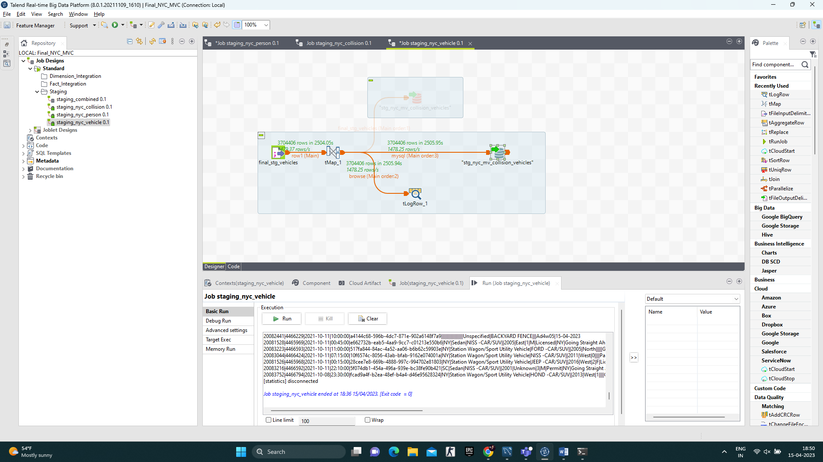

**stg_nyc_mv_collision_persons:**

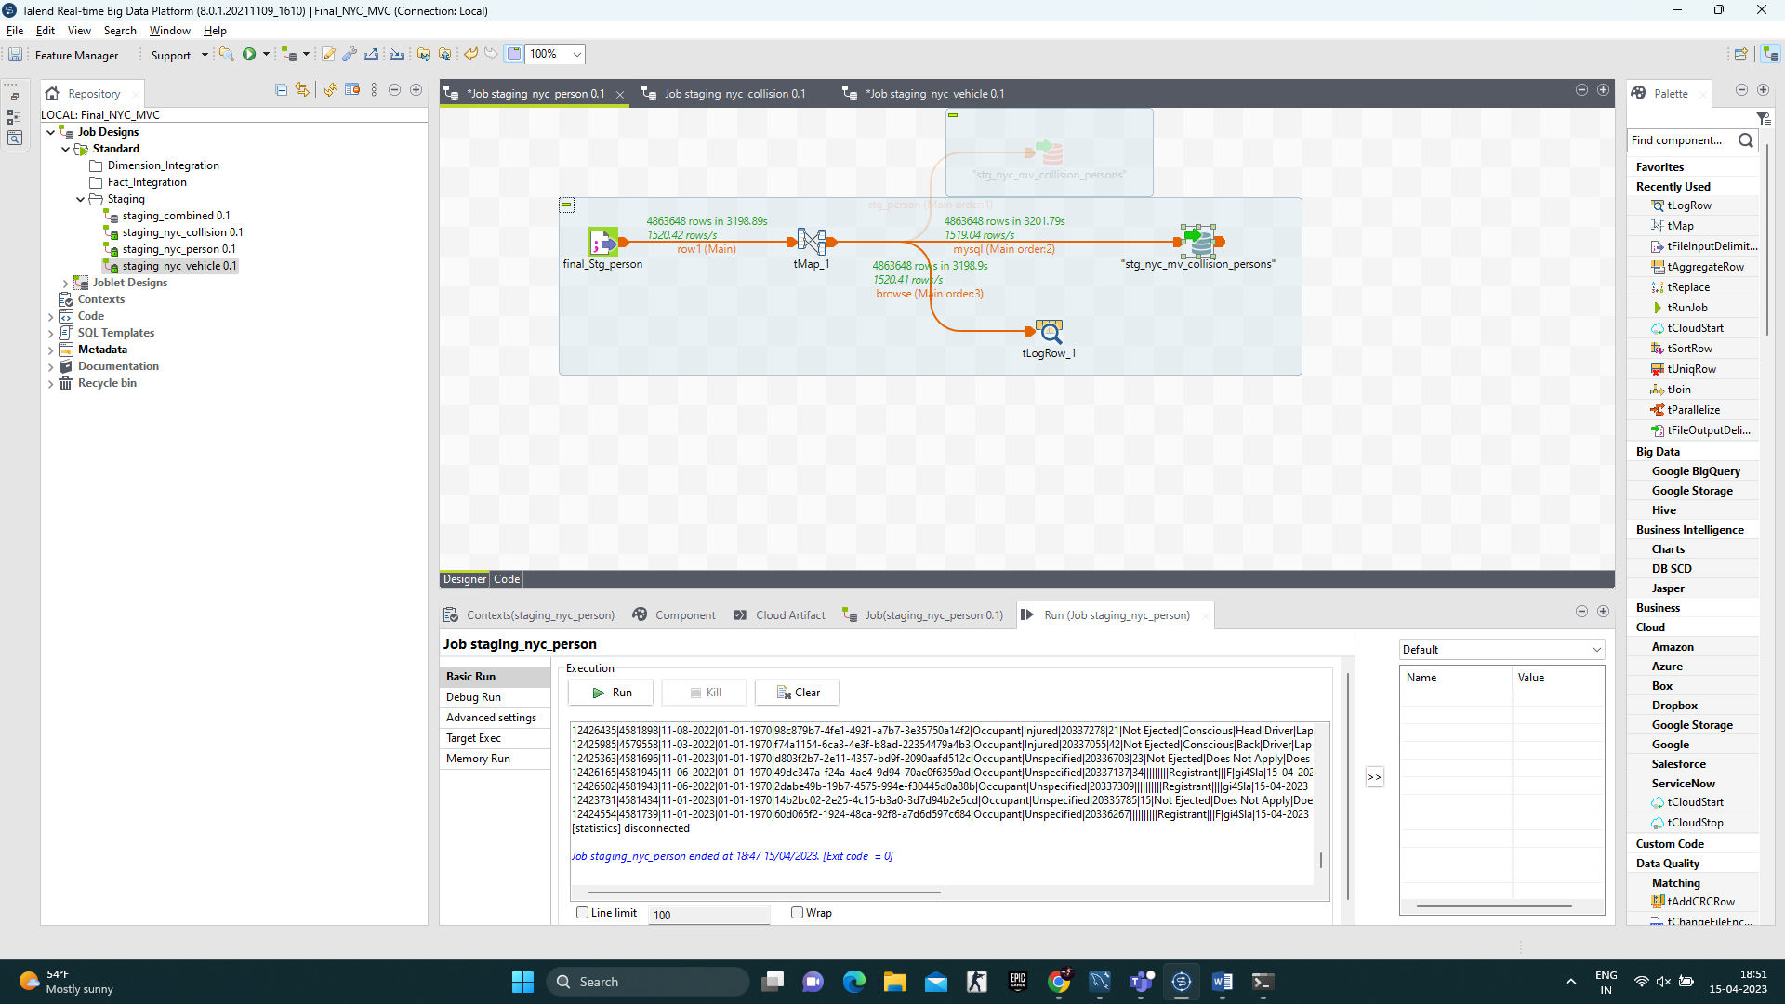

**stg_nyc_mv_collisions_bigquery:**

